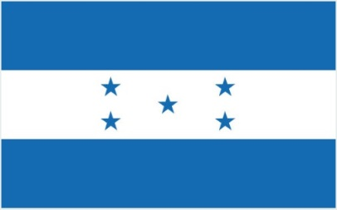
PLEASURE CRAFT SAFETY CERTIFICATE

Vessels of 6 meters in length and above
Issued under the provisions of DECREE No. 18 – 30/05/1984 Under the authority of the Government of

THE MERCHANT MARINE HONDURAS

By GR CLASS CLASSIFIED FOR STANDARD (GR CLASS)

PLECE NO.

Name Ship | Type | Distinctive number or letters | Port of registry | Gross tonnage | Keel laid
 |  | Length (in m)

Type of pleasure craft1:
Sailboat
Motor Ves sel Motor Boat
Inboard/Outboard

Authorized for voyages proceeding not further than miles from shore.

The survey has shown that:

- The life-saving appliances provided for a total number of persons and no more, viz:

Select as appropriate1capable of accommodating persons;

Motor boats (included in the total shown above);

Liferafts, for which approved launching devices are not required, capable of accommodating persons;

Liferafts, for which approved launching devices are required, capable of accommodating persons;

Lifebuoys;

Lifejackets;

- That the lifeboats and liferafts were equipped in accordance with the provisions of the Rules.

This certificate is valid until
(YYYY-MM-DD)

Completion date of the survey on which this certificate is based
(YYYY-MM-DD)

Issued at Date of issue
(YYYY-MM-DD)
(Place of issue of certificate)

GR CLASS REPRESENTATIVE

1Select as appropriate

GR CLASS – CLASSIFIED FOR STANDARD (GR CLASS)

E-mail: info@grclass.com Web: www.grclass.com

Form PLECE-FT Approved by: GM Page 1 of 1

